Top 10 Private Hospitals in Bhubaneswar (2025) – Best Medical Care in Odisha
Let’s discover the top 10 best private hospitals in Bhubaneswar, Odisha for 2025. Details on facilities, specialties, emergency care, and contact info.



Introduction
Bhubaneswar is emerging as a major medical hub in Eastern India, offering advanced and affordable healthcare. With numerous private hospitals equipped with modern infrastructure, expert doctors, and 24x7 emergency care, the city ensures residents and visitors get the best treatment. Here's a curated list of the Top 10 Private Hospitals in Bhubaneswar, based on services, patient feedback, and specialties.
List of Top 10 Private Hospitals in Bhubaneswar
1. SUM Ultimate Medicare
Location: Kalinga Nagar


Website: sumhospital.in

Specialties: Oncology, Cardiology, Neurology
Why Choose: World-class facilities and NABH accredited
Why it's Best:
✅World-class ICU and oncology services
✅Patient- centered design and facilities
✅Empanelled under various insurance schemes
2 . Care Hospitals Bhubaneswar
Location: Prachi Enclave, Chandrasekharpur

Website: carehospitals.com
Specialties: Cardiac, Renal Care, Diabetes
Why Choose: Cost-effective and advanced care
Why it's Best:
✅Known for their best cardiac and orthopedic departments
✅Affordable diagnostic packages
✅Friendly staff and quick response time
3. KIMS Hospital (Kalinga Institute of Medical Sciences)
Location: Patia


Website: kims.kiit.ac.in
Specialties: Multispecialty, Emergency, Organ Transplants
Why Choose: Trusted for affordable quality care with academic excellence
Why it's Best:
✅NABH accredited
✅Advanced trauma care & emergency services
✅Affordable treatment and research-oriented care
4. Apollo Hospitals
Location: Sainik School Road
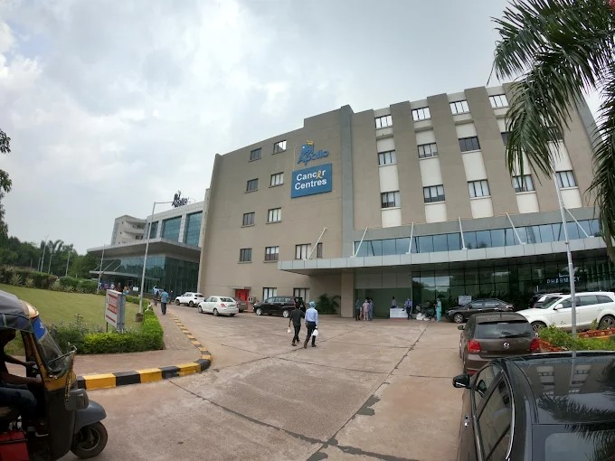

Website: apollohospitals.com
Specialties: Cardiology, Orthopedics, Robotic Surgery
Why Choose: National brand with global standards
Why it's Best:
✅Part of India’s leading hospital chain
✅24x7 emergency, robotic surgeries, and cardiology
✅High patient satisfaction and cleanliness
5. Manipal Hospitals, Bhubaneswar
Location: Khandagiri, Bhubaneswar 751 030


Website: manipalhospitals.com/bhubaneswar
Specialities: Cardiac Science, Orthopedics, Neuro Sciences, Gastro Science
Why Choose: At Manipal Hospitals, Bhubaneswar they are not just treating illnesses, they are building a healthier future, one patient and one community at a time.
Why It’s Best:
✅Accident and Emergency Care , Anesthesiology Cardiology Cardiothoracic ✅Vascular Surgery, Dialysis , Gastrointestinal Science, Laparoscopic Surgery, ✅Liver Transplantation Surgery
6. Utkal Hospital
Location: Defence Colony Rd, Neeladri Vihar, Chandrasekharpur,
Bhubaneswar, Odisha 751021
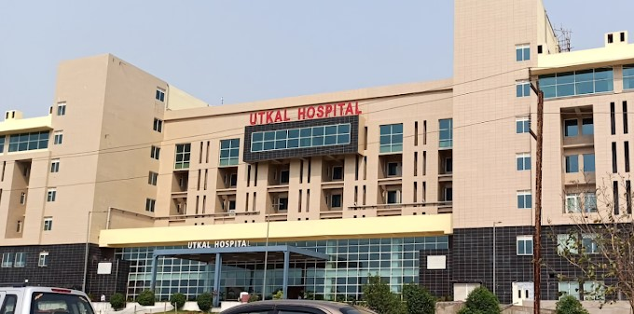

Website: utkalhospital.com
Specialties: Orthopedics, Neurology, General Surgery
Why Choose: Modern equipment with great patient satisfaction
Why it’s Best:
✅ Offers modern diagnostic and surgical facilities
✅Good for orthopedics, neurology, and general surgery
✅ Affordable private care with quality service
7. Sparsh Hospitals
Location: Saheed Nagar


Website: sparshhospitals.com
Specialties: Trauma, Maternity, Pediatrics
Why Choose: Known for surgical excellence and patient-centric care
Why it’s Best:
✅ Known for trauma care, maternity, and pediatric services
✅Highly experienced team of surgeons and specialists
✅Quick emergency response and patient-friendly staff

8. Bluewheel Hospital
Location: Pahala
Website: bluewheelhospital.org
Specialties: IVF, Pediatrics, Orthopedics
Why Choose: Affordable maternity and fertility care
Why It’s Best:
✅ Specialized in IVF, maternity, and pediatric care
✅ Affordable packages for fertility treatments
✅ Clean, well-maintained facility with compassionate doctors
9. Kar Clinic & Hospital
Location: Unit-4, Madhusudan Nagar
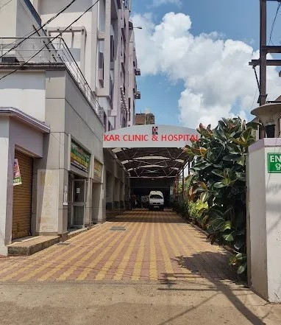
Website: karhospitals.com
Specialties: Gynecology, General Medicine, ENT
Why Choose: Good for OPD, diagnostics, and maternity services
Why It’s Best:
✅ Convenient for outpatient services, diagnostics, and minor surgeries
✅ Trusted by locals for gynecology, ENT, and general medicine
✅ Central location makes it easily accessible
10. Vivekananda Hospital
Location: Khandagiri
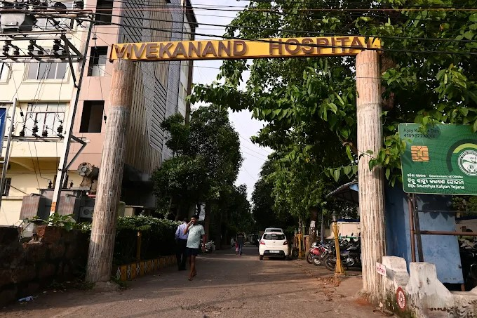

Website: vivekanandahospital.com
Specialties: Physiotherapy, General Medicine, Diagnostics
Why Choose: Budget-friendly care for local residents
Why It’s Best:
✅ Budget-friendly private hospital with basic specialties
✅ Good for physiotherapy, rehabilitation, and diagnostics
✅ Focuses on patient comfort and affordable treatment

Comparison Table
Hospital Name | Location | Key Specialties | NABH Accredited | 24x7 Emergency
SUM Ultimate | Kalinga Nagar | Oncology, Cardiology | ✅ | ✅
KIMS | Patia | Multispecialty | ✅ | ✅
Apollo Hospitals | Sainik School Rd | Cardio, Robotic Surgery | ✅ | ✅
AMRI Hospitals | Khandagiri | Internal, Neurology | ✅ | ✅
Care Hospitals | Chandrasekharpur | Cardio, Renal | ✅ | ✅
Utkal Hospital | Kalpana Square | Ortho, Neuro | ❌ | ✅
Sparsh Hospitals | Saheed Nagar | Trauma, Maternity | ❌ | ✅
Bluewheel Hospital | Pahala | IVF, Ortho | ❌ | ✅
Kar Clinic | Unit-4 | Gynecology, ENT | ❌ | ✅
Vivekananda Hospital | Khandagiri | Physiotherapy | ❌ | ✅

✅ Conclusion
Bhubaneswar’s private healthcare sector is growing rapidly, offering affordable and accessible treatment options for every need. Whether you seek specialized surgery, emergency care, or diagnostics, these top 10 private hospitals stand out for quality, service, and trust.

